Information Design & Taxonomy
This is the planning and documentation of a website for a culinary institution. In this section, an overview of the information architecture, site navigation, and storyboard flowchart will be clearly shown and discussed.
As stated above, the website is for a Culinary Institute called Dikapei Culinary School, which was recently established in Gaborone. This website is for people of the ages of 13-75 interested in learning about food and cooking. The website gives access to courses available at the institute, a little information about the school’s background, and information on the available cuisines, its exact location, and operation times. This website is to ensure more people have knowledge of the institution’s existence and ease of access to available resources.

Information Architecture
The website is well arranged user-friendly sections that show exactly what the institution has to offer and its body structure. Each section of the website is designed to certify ease of use:
Home Page
Welcome message Search bar Featured programs Latest announcements

About Us
School background(founded when and by who) Institution tour School Staff

Programs
- Diplomas
Diploma in Culinary Arts
Diploma in Hospitality & Culinary Management
Diploma in Baking & Pastry Arts

- Certificates
Certificate in Food Preparation & Cooking
Certificate in Food & Beverage Preparation
Certificate in Nutrition

- Short Courses
Wine Tasting & Pairing
Food Photography & Styling
Cake Decorating & Sugar Craft

- Professional Programs
Restaurant Entrepreneurship
Catering & Event Management

Admissions Application process Tuition & fees

Announcements
Upcoming events

Contact Us
Location Operating hours Contact details( numbers, email address)

Site Map
The map below shows how the end users will navigate through the website:
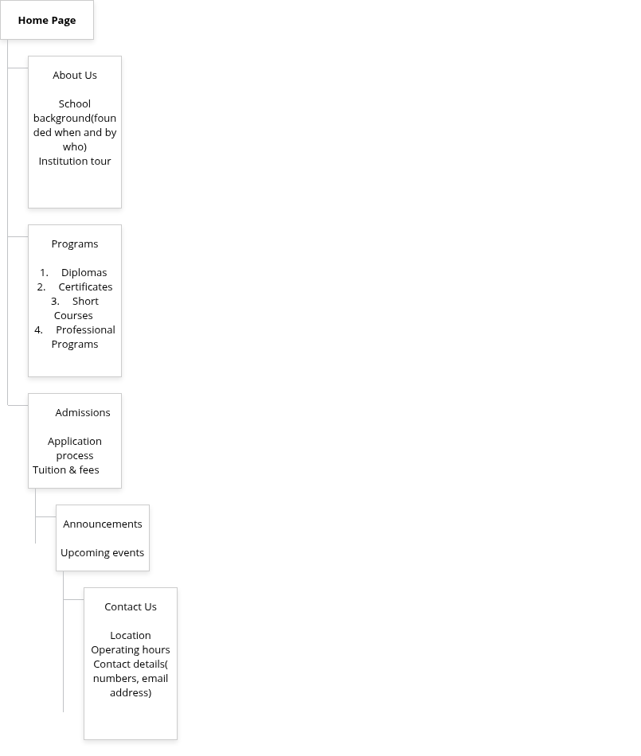

Storyboard Flowchart
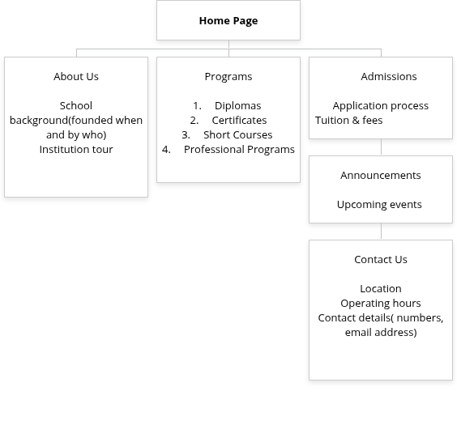
Guide on what the flowchart represents:
The home page is the foundation of the entire website
On the website, there are five(5) main categories being; About Us, Programs, Admissions, Announcements, and Contact Us
Then those categories are divided into sub-pages as shown below:
-About Us- School background(founded when and by who), institution tour, and school staff
-Programs- Diplomas, certificates, short courses, and professional programs
-Admissions- Application process, Tuition & fees
-Announcements- Upcoming events
-Contact Us- Location, Operating hours, Contact details (numbers, email address)

Documentation Navigation
Home page provides access to all major sections using a navigation bar at the top

About Us School background: information on the founding of the school
Institution tour: overview of the school’s facilities and infrastructure

Programs
Diplomas: the highest level of qualification offered at the institution
Certificates: specialized short courses
Short courses: flexible learning options
Professional programs: career training-oriented courses

Admissions Application Process: step-by-step guide for applicants Tuition & Fees: a detailed description of financial requirements

Announcements Upcoming events: institution academic calendar and workshops

Contact Us Location: physical address and map Operating hours: service availability Contact details: phone number and email addresses

